Assignment-3 (30 points)
Recursive Functions
Due date: 9/13/2022

Exercise-1: (7.5 points)
Write a recursive Python function that has a parameter representing a list of integers and returns the maximum stored in the list. Thinking recursively, the maximum is either the first value in the list or the maximum of the rest of the list, whichever is larger. If the list only has 1 integer, then its maximum is this single value, naturally. Copy and paste the screenshot of the result.

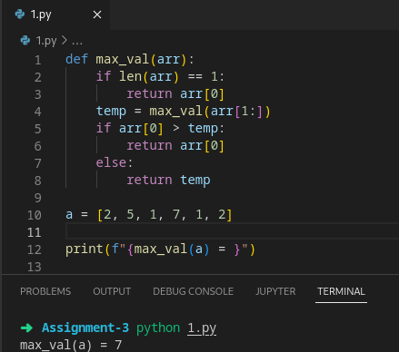

Exercise-2: (7.5 points)
Run the Recursive Fibonacci function defined in the class notes with input a) 50 and b) 115. Copy and paste the screenshot of the result. Explain your understanding about this recursive function and the iterative function which you have written for your earlier assignment.

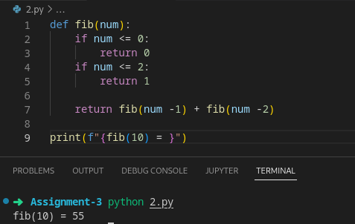

Note:
If the program doesn’t work, test it with lesser values (let’s say 10 or 15) and record your observations.

This recursive fuction, every time it is called it calls itself two addictional times, and those sub calls do the same which make the function calls exploded exponentially thus slowing the program down to an immense level

Exercise-3: (7.5 points)
Write a recursive function to calculate the sum of the positive integers of n+(n-2)+(n-4)...
Copy and paste the screenshot of the result.

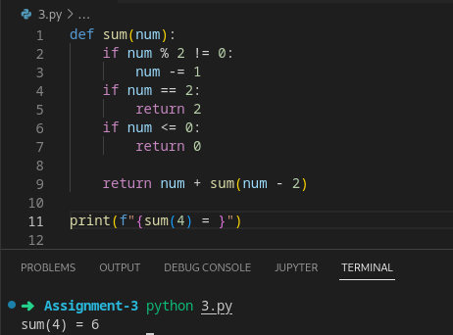

Exercise-4: (7.5 points)
Write a recursive function to calculate the value of 'a' to the power 'b'? Copy and paste the screenshot of the result.

